# This task is a base for this issue:
# SD#2256003

#
# 20190211
#
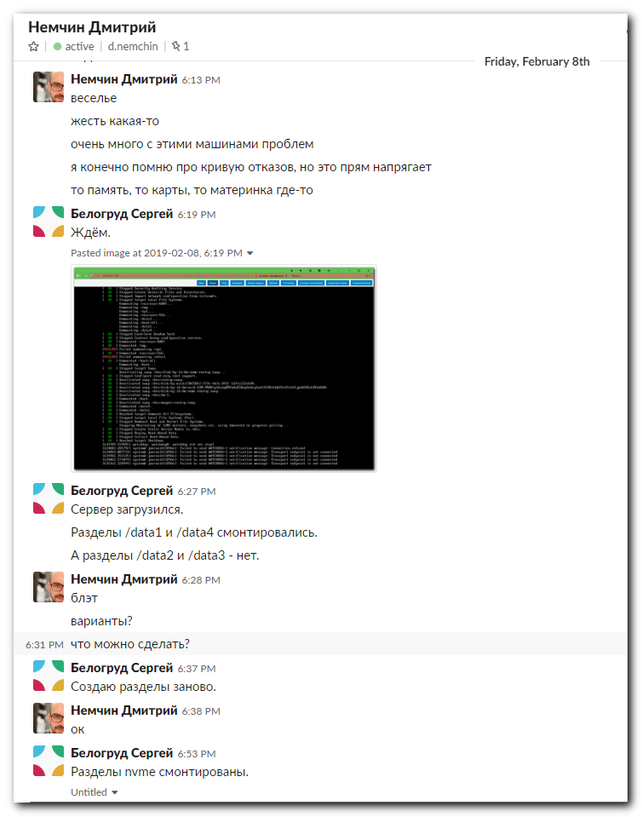
...........................................................................

Леонов Алексей [12:11 PM]
коллеги, сталкивался кто нибудь
nvme smart-log /dev/nvme1n1
NVMe Status:NS_NOT_READY: The namespace is not ready to be accessed(82)?

Леонов Алексей [12:37 PM]
вобщем, пока не знаю что произошло. после перезагрузки ds-gp-prod контура отвалилось по io error 3 nvme
гп админы сказали, что данные смогут восстановить, потому чинил так
Untitled
[12:34:01 root@ds-gp-prod-sdw35 a.leonov]# nvme smart-log /dev/nvme0n1
NVMe Status:NS_NOT_READY: The namespace is not ready to be accessed(82)
[12:34:17 root@ds-gp-prod-sdw35 a.leonov]# nvme format /dev/nvme0 -n 1 -r
Success formatting namespace:1
[12:34:33 root@ds-gp-prod-sdw35 a.leonov]# parted /dev/nvme0n1
GNU Parted 3.1
Using /dev/nvme0n1
Welcome to GNU Parted! Type 'help' to view a list of commands.
(parted) mklabel gpt
(parted) mkpart
Partition name? []? nvme01
File system type? [ext2]? xfs
Start? 1M
End? 100%
(parted) q
Information: You may need to update /etc/fstab.
?
[12:36:02 root@ds-gp-prod-sdw35 a.leonov]# mkfs.xfs /dev/nvme0n1p1
meta-data=/dev/nvme0n1p1 isize=512 agcount=4, agsize=195350976 blks
= sectsz=512 attr=2, projid32bit=1
= crc=1 finobt=0, sparse=0
data = bsize=4096 blocks=781403904, imaxpct=5
= sunit=0 swidth=0 blks
naming =version 2 bsize=4096 ascii-ci=0 ftype=1
log =internal log bsize=4096 blocks=381544, version=2
= sectsz=512 sunit=0 blks, lazy-count=1
realtime =none extsz=4096 blocks=0, rtextents=0
[12:36:16 root@ds-gp-prod-sdw35 a.leonov]# vim /etc/fstab
[12:36:26 root@ds-gp-prod-sdw35 a.leonov]# mount /data1
Collapse

т.е отформатировал неймспейс, который не отвечал и ресетнул контроллер.
создал таблицу, раздел и фс заново.

...........................................................................

#
# Before reboot server, needs to comment four rows in /etc/fstab!
#

[18:47:17 root@ds-gp-prod-sdw13 ~]# cat /etc/fstab

#
# /etc/fstab
# Created by anaconda on Thu Dec 20 14:22:28 2018
#
# Accessible filesystems, by reference, are maintained under '/dev/disk'
# See man pages fstab(5), findfs(8), mount(8) and/or blkid(8) for more info
#
/dev/mapper/rootvg-root / ext4 defaults 1 1
UUID=73c0961e-4451-4e6b-addd-07471c1a4d8f /boot ext4 defaults 1 2
UUID=5A1D-580D /boot/efi vfat defaults,uid=0,gid=0,umask=0077,shortname=winnt 0 0
/dev/mapper/rootvg-opt /opt ext4 defaults 1 2
/dev/mapper/rootvg-tmp /tmp ext4 defaults 1 2
/dev/mapper/rootvg-var /var ext4 defaults 1 2
/dev/mapper/rootvg-swap swap swap defaults 0 0
PARTLABEL=nvme01 /data1 xfs allocsize=16m,nodev,noatime,nobarrier,inode64 0 0
PARTLABEL=nvme02 /data2 xfs allocsize=16m,nodev,noatime,nobarrier,inode64 0 0
PARTLABEL=nvme03 /data3 xfs allocsize=16m,nodev,noatime,nobarrier,inode64 0 0
PARTLABEL=nvme04 /data4 xfs allocsize=16m,nodev,noatime,nobarrier,inode64 0 0
[18:47:27 root@ds-gp-prod-sdw13 ~]#

[18:49:44 root@ds-gp-prod-sdw13 ~]# lsblk
NAME MAJ:MIN RM SIZE RO TYPE MOUNTPOINT
sda 8:0 0 744.6G 0 disk
+-sda1 8:1 0 200M 0 part /boot/efi
+-sda2 8:2 0 1G 0 part /boot
L-sda3 8:3 0 743.4G 0 part
+-rootvg-root 253:0 0 150G 0 lvm /
+-rootvg-swap 253:1 0 16G 0 lvm [SWAP]
+-rootvg-opt 253:2 0 50G 0 lvm /opt
+-rootvg-var 253:3 0 100G 0 lvm /var
L-rootvg-tmp 253:4 0 8G 0 lvm /tmp
nvme0n1 259:0 0 2.9T 0 disk
L-nvme0n1p1 259:2 0 2.9T 0 part /data1
nvme1n1 259:4 0 2.9T 0 disk
L-nvme1n1p1 259:6 0 2.9T 0 part
nvme2n1 259:5 0 2.9T 0 disk
nvme3n1 259:1 0 2.9T 0 disk
L-nvme3n1p1 259:3 0 2.9T 0 part /data4
[18:50:00 root@ds-gp-prod-sdw13 ~]#

[18:51:43 root@ds-gp-prod-sdw13 ~]# nvme format /dev/nvme2 -n 1 -r
Success formatting namespace:1
[18:52:22 root@ds-gp-prod-sdw13 ~]# parted -s -a optimal /dev/nvme2n1 mklabel GPT print mkpart primary xfs 0% 100% name 1 'nvme03' print
Model: NVMe Device (nvme)
Disk /dev/nvme2n1: 3201GB
Sector size (logical/physical): 512B/512B
Partition Table: gpt
Disk Flags:

Number Start End Size File system Name Flags

Model: NVMe Device (nvme)
Disk /dev/nvme2n1: 3201GB
Sector size (logical/physical): 512B/512B
Partition Table: gpt
Disk Flags:

Number Start End Size File system Name Flags
1 1049kB 3201GB 3201GB nvme03

[18:52:28 root@ds-gp-prod-sdw13 ~]#

[18:52:28 root@ds-gp-prod-sdw13 ~]# mkfs.xfs /dev/nvme2n1p1
meta-data=/dev/nvme2n1p1 isize=512 agcount=4, agsize=195350976 blks
= sectsz=512 attr=2, projid32bit=1
= crc=1 finobt=0, sparse=0
data = bsize=4096 blocks=781403904, imaxpct=5
= sunit=0 swidth=0 blks
naming =version 2 bsize=4096 ascii-ci=0 ftype=1
log =internal log bsize=4096 blocks=381544, version=2
= sectsz=512 sunit=0 blks, lazy-count=1
realtime =none extsz=4096 blocks=0, rtextents=0
[18:52:45 root@ds-gp-prod-sdw13 ~]# mount /data3
[18:52:48 root@ds-gp-prod-sdw13 ~]# df -hT /data*
Filesystem Type Size Used Avail Use% Mounted on
/dev/nvme0n1p1 xfs 3.0T 297G 2.7T 10% /data1
/dev/nvme1n1p1 xfs 3.0T 33M 3.0T 1% /data2
/dev/nvme2n1p1 xfs 3.0T 33M 3.0T 1% /data3
/dev/nvme3n1p1 xfs 3.0T 296G 2.7T 10% /data4
[18:52:54 root@ds-gp-prod-sdw13 ~]#

[18:52:54 root@ds-gp-prod-sdw13 ~]# lsblk
NAME MAJ:MIN RM SIZE RO TYPE MOUNTPOINT
sda 8:0 0 744.6G 0 disk
+-sda1 8:1 0 200M 0 part /boot/efi
+-sda2 8:2 0 1G 0 part /boot
L-sda3 8:3 0 743.4G 0 part
+-rootvg-root 253:0 0 150G 0 lvm /
+-rootvg-swap 253:1 0 16G 0 lvm [SWAP]
+-rootvg-opt 253:2 0 50G 0 lvm /opt
+-rootvg-var 253:3 0 100G 0 lvm /var
L-rootvg-tmp 253:4 0 8G 0 lvm /tmp
nvme0n1 259:0 0 2.9T 0 disk
L-nvme0n1p1 259:2 0 2.9T 0 part /data1
nvme1n1 259:4 0 2.9T 0 disk
L-nvme1n1p1 259:6 0 2.9T 0 part /data2
nvme2n1 259:5 0 2.9T 0 disk
L-nvme2n1p1 259:7 0 2.9T 0 part /data3
nvme3n1 259:1 0 2.9T 0 disk
L-nvme3n1p1 259:3 0 2.9T 0 part /data4
[18:56:29 root@ds-gp-prod-sdw13 ~]#

[18:56:29 root@ds-gp-prod-sdw13 ~]# parted /dev/nvme2n1 print
Model: NVMe Device (nvme)
Disk /dev/nvme2n1: 3201GB
Sector size (logical/physical): 512B/512B
Partition Table: gpt
Disk Flags:

Number Start End Size File system Name Flags
1 1049kB 3201GB 3201GB xfs nvme03

[18:57:05 root@ds-gp-prod-sdw13 ~]#

...........................................................................
...........................................................................
...........................................................................
#
# Here is another example from other server. As we can see there is no one block device at all.
[s.belogrud@TCS4357]# ssh bsv@ds-gp-prod-sdw35
Warning: Permanently added 'ds-gp-prod-sdw35' (ECDSA) to the list of known hosts.
[bsv@ds-gp-prod-sdw35 ~]$ sudo -i

We trust you have received the usual lecture from the local System
Administrator. It usually boils down to these three things:

#1) Respect the privacy of others.
#2) Think before you type.
#3) With great power comes great responsibility.

[sudo] password for bsv:
[19:21:25 root@ds-gp-prod-sdw35 ~]#
[19:21:25 root@ds-gp-prod-sdw35 ~]# lsblk
NAME MAJ:MIN RM SIZE RO TYPE MOUNTPOINT
sda 8:0 0 744.6G 0 disk
+-sda1 8:1 0 200M 0 part /boot/efi
+-sda2 8:2 0 1G 0 part /boot
L-sda3 8:3 0 743.4G 0 part
+-rootvg-root 253:0 0 150G 0 lvm /
+-rootvg-swap 253:1 0 16G 0 lvm [SWAP]
+-rootvg-opt 253:2 0 50G 0 lvm /opt
+-rootvg-var 253:3 0 100G 0 lvm /var
L-rootvg-tmp 253:4 0 8G 0 lvm /tmp
nvme0n1 259:6 0 2.9T 0 disk
L-nvme0n1p1 259:7 0 2.9T 0 part
nvme1n1 259:4 0 2.9T 0 disk
L-nvme1n1p1 259:5 0 2.9T 0 part /data2
nvme3n1 259:1 0 2.9T 0 disk
L-nvme3n1p1 259:3 0 2.9T 0 part /data4
[19:21:29 root@ds-gp-prod-sdw35 ~]# umount /data2
[19:22:32 root@ds-gp-prod-sdw35 ~]# umount /data4
[19:23:07 root@ds-gp-prod-sdw35 ~]# vim /etc/fstab
[19:25:33 root@ds-gp-prod-sdw35 ~]# shutdown -r now
WARNING !!! Going to start shutdown on server ds-gp-prod-sdw35 in 60 seconds ! Press Ctrl+C if you not sure
Connection reset by 10.217.100.35
[s.belogrud@TCS4357]#

[s.belogrud@TCS4357]# ssh bsv@ds-gp-prod-sdw35
Last login: Fri Feb 8 19:21:19 2019 from 172.16.28.74
[bsv@ds-gp-prod-sdw35 ~]$ sudo -i
[sudo] password for bsv:
[19:35:57 root@ds-gp-prod-sdw35 ~]#

[19:35:58 root@ds-gp-prod-sdw35 ~]# lsblk
NAME MAJ:MIN RM SIZE RO TYPE MOUNTPOINT
sda 8:0 0 744.6G 0 disk
+-sda1 8:1 0 200M 0 part /boot/efi
+-sda2 8:2 0 1G 0 part /boot
L-sda3 8:3 0 743.4G 0 part
+-rootvg-root 253:0 0 150G 0 lvm /
+-rootvg-swap 253:1 0 16G 0 lvm [SWAP]
+-rootvg-opt 253:2 0 50G 0 lvm /opt
+-rootvg-var 253:3 0 100G 0 lvm /var
L-rootvg-tmp 253:4 0 8G 0 lvm /tmp
nvme0n1 259:0 0 2.9T 0 disk
L-nvme0n1p1 259:2 0 2.9T 0 part
nvme1n1 259:1 0 2.9T 0 disk
L-nvme1n1p1 259:3 0 2.9T 0 part
nvme2n1 259:6 0 2.9T 0 disk
nvme3n1 259:4 0 2.9T 0 disk
L-nvme3n1p1 259:5 0 2.9T 0 part
[19:36:00 root@ds-gp-prod-sdw35 ~]# mount /data1
mount: can't find /data1 in /etc/fstab
[19:36:08 root@ds-gp-prod-sdw35 ~]# vim /etc/fstab
[19:36:23 root@ds-gp-prod-sdw35 ~]# tail -n 4 /etc/fstab
PARTLABEL=nvme01 /data1 xfs allocsize=16m,nodev,noatime,nobarrier,inode64 0 0
PARTLABEL=nvme02 /data2 xfs allocsize=16m,nodev,noatime,nobarrier,inode64 0 0
PARTLABEL=nvme03 /data3 xfs allocsize=16m,nodev,noatime,nobarrier,inode64 0 0
PARTLABEL=nvme04 /data4 xfs allocsize=16m,nodev,noatime,nobarrier,inode64 0 0
[19:36:28 root@ds-gp-prod-sdw35 ~]# mount /data1
[19:36:35 root@ds-gp-prod-sdw35 ~]# mount /data2
[19:36:41 root@ds-gp-prod-sdw35 ~]# mount /data4
[19:36:43 root@ds-gp-prod-sdw35 ~]# nvme smart-log /dev/nvme2n1
NVMe Status:NS_NOT_READY: The namespace is not ready to be accessed(82)
[19:37:28 root@ds-gp-prod-sdw35 ~]# nvme format /dev/nvme2 -n 1 -r
Success formatting namespace:1
[19:38:07 root@ds-gp-prod-sdw35 ~]# lsblk
NAME MAJ:MIN RM SIZE RO TYPE MOUNTPOINT
sda 8:0 0 744.6G 0 disk
+-sda1 8:1 0 200M 0 part /boot/efi
+-sda2 8:2 0 1G 0 part /boot
L-sda3 8:3 0 743.4G 0 part
+-rootvg-root 253:0 0 150G 0 lvm /
+-rootvg-swap 253:1 0 16G 0 lvm [SWAP]
+-rootvg-opt 253:2 0 50G 0 lvm /opt
+-rootvg-var 253:3 0 100G 0 lvm /var
L-rootvg-tmp 253:4 0 8G 0 lvm /tmp
nvme0n1 259:0 0 2.9T 0 disk
L-nvme0n1p1 259:2 0 2.9T 0 part /data1
nvme1n1 259:1 0 2.9T 0 disk
L-nvme1n1p1 259:3 0 2.9T 0 part /data2
nvme2n1 259:6 0 2.9T 0 disk
nvme3n1 259:4 0 2.9T 0 disk
L-nvme3n1p1 259:5 0 2.9T 0 part /data4
[19:38:25 root@ds-gp-prod-sdw35 ~]# parted -s -a optimal /dev/nvme2n1 mklabel GPT print mkpart primary xfs 0% 100% name 1 'nvme03' print
Model: NVMe Device (nvme)
Disk /dev/nvme2n1: 3201GB
Sector size (logical/physical): 512B/512B
Partition Table: gpt
Disk Flags:

Number Start End Size File system Name Flags

Model: NVMe Device (nvme)
Disk /dev/nvme2n1: 3201GB
Sector size (logical/physical): 512B/512B
Partition Table: gpt
Disk Flags:

Number Start End Size File system Name Flags
1 1049kB 3201GB 3201GB nvme03

[19:38:53 root@ds-gp-prod-sdw35 ~]# lsblk
NAME MAJ:MIN RM SIZE RO TYPE MOUNTPOINT
sda 8:0 0 744.6G 0 disk
+-sda1 8:1 0 200M 0 part /boot/efi
+-sda2 8:2 0 1G 0 part /boot
L-sda3 8:3 0 743.4G 0 part
+-rootvg-root 253:0 0 150G 0 lvm /
+-rootvg-swap 253:1 0 16G 0 lvm [SWAP]
+-rootvg-opt 253:2 0 50G 0 lvm /opt
+-rootvg-var 253:3 0 100G 0 lvm /var
L-rootvg-tmp 253:4 0 8G 0 lvm /tmp
nvme0n1 259:0 0 2.9T 0 disk
L-nvme0n1p1 259:2 0 2.9T 0 part /data1
nvme1n1 259:1 0 2.9T 0 disk
L-nvme1n1p1 259:3 0 2.9T 0 part /data2
nvme2n1 259:6 0 2.9T 0 disk
L-nvme2n1p1 259:7 0 2.9T 0 part
nvme3n1 259:4 0 2.9T 0 disk
L-nvme3n1p1 259:5 0 2.9T 0 part /data4
[19:39:11 root@ds-gp-prod-sdw35 ~]# mkfs.xfs /dev/nvme2n1p1
meta-data=/dev/nvme2n1p1 isize=512 agcount=4, agsize=195350976 blks
= sectsz=512 attr=2, projid32bit=1
= crc=1 finobt=0, sparse=0
data = bsize=4096 blocks=781403904, imaxpct=5
= sunit=0 swidth=0 blks
naming =version 2 bsize=4096 ascii-ci=0 ftype=1
log =internal log bsize=4096 blocks=381544, version=2
= sectsz=512 sunit=0 blks, lazy-count=1
realtime =none extsz=4096 blocks=0, rtextents=0
[19:39:25 root@ds-gp-prod-sdw35 ~]# mount /data3
[19:39:36 root@ds-gp-prod-sdw35 ~]# lsblk
NAME MAJ:MIN RM SIZE RO TYPE MOUNTPOINT
sda 8:0 0 744.6G 0 disk
+-sda1 8:1 0 200M 0 part /boot/efi
+-sda2 8:2 0 1G 0 part /boot
L-sda3 8:3 0 743.4G 0 part
+-rootvg-root 253:0 0 150G 0 lvm /
+-rootvg-swap 253:1 0 16G 0 lvm [SWAP]
+-rootvg-opt 253:2 0 50G 0 lvm /opt
+-rootvg-var 253:3 0 100G 0 lvm /var
L-rootvg-tmp 253:4 0 8G 0 lvm /tmp
nvme0n1 259:0 0 2.9T 0 disk
L-nvme0n1p1 259:2 0 2.9T 0 part /data1
nvme1n1 259:1 0 2.9T 0 disk
L-nvme1n1p1 259:3 0 2.9T 0 part /data2
nvme2n1 259:6 0 2.9T 0 disk
L-nvme2n1p1 259:7 0 2.9T 0 part /data3
nvme3n1 259:4 0 2.9T 0 disk
L-nvme3n1p1 259:5 0 2.9T 0 part /data4
[19:39:47 root@ds-gp-prod-sdw35 ~]# df -hT /data*
Filesystem Type Size Used Avail Use% Mounted on
/dev/nvme0n1p1 xfs 3.0T 284G 2.7T 10% /data1
/dev/nvme1n1p1 xfs 3.0T 296G 2.7T 10% /data2
/dev/nvme2n1p1 xfs 3.0T 33M 3.0T 1% /data3
/dev/nvme3n1p1 xfs 3.0T 296G 2.7T 10% /data4
[19:39:55 root@ds-gp-prod-sdw35 ~]# logout
[bsv@ds-gp-prod-sdw35 ~]$ logout
Connection to ds-gp-prod-sdw35 closed.
[s.belogrud@TCS4357]#

#
# A case, opened on RedHat support.
https://access.redhat.com/support/cases/#/case/02314465?commentId=a0a2K00000OmRyuQAF

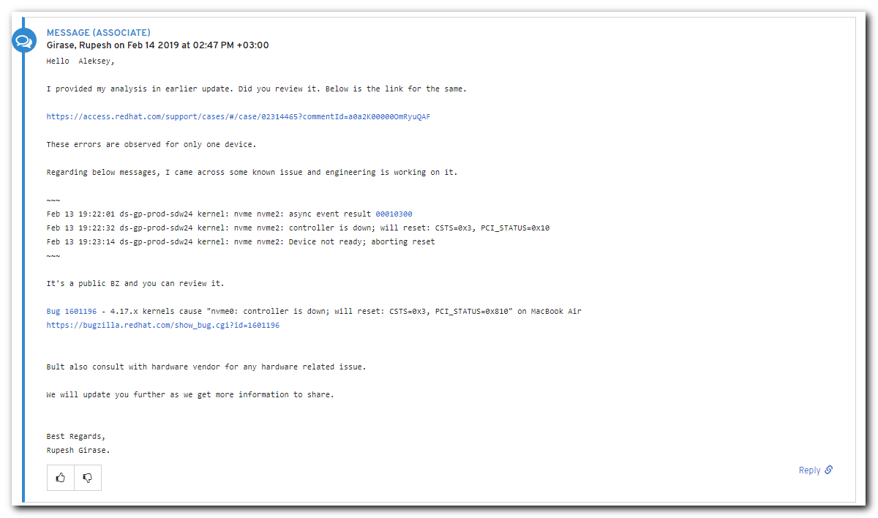

#
# 20190220
# Some info, that could be useful

[11:59:03 root@ds-gp-front-sdw01 ~]# nvme list
Node SN Model Namespace Usage Format FW Rev
---------------- -------------------- ---------------------------------------- --------- -------------------------- ---------------- --------
/dev/nvme0n1 S39XNX0K300779 Dell Express Flash PM1725a 1.6TB SFF 1 1.60 TB / 1.60 TB 512 B + 0 B 1.1.1
/dev/nvme1n1 S39XNX0K300780 Dell Express Flash PM1725a 1.6TB SFF 1 1.60 TB / 1.60 TB 512 B + 0 B 1.1.1
/dev/nvme2n1 S39XNX0K300696 Dell Express Flash PM1725a 1.6TB SFF 1 1.60 TB / 1.60 TB 512 B + 0 B 1.1.1
/dev/nvme3n1 S39XNX0K300778 Dell Express Flash PM1725a 1.6TB SFF 1 1.60 TB / 1.60 TB 512 B + 0 B 1.1.1
[11:59:23 root@ds-gp-front-sdw01 ~]#

[11:48:57 root@ds-gp-front-sdw01 ~]# nvme --help
nvme-1.6
usage: nvme <command> [<device>] [<args>]

The '<device>' may be either an NVMe character device (ex: /dev/nvme0) or an
nvme block device (ex: /dev/nvme0n1).

The following are all implemented sub-commands:
list List all NVMe devices and namespaces on machine
list-subsys List nvme subsystems
id-ctrl Send NVMe Identify Controller
id-ns Send NVMe Identify Namespace, display structure
list-ns Send NVMe Identify List, display structure
ns-descs Send NVMe Namespace Descriptor List, display structure
id-nvmset Sned NVMe Identify NVM Set List, display structure
create-ns Creates a namespace with the provided parameters
delete-ns Deletes a namespace from the controller
attach-ns Attaches a namespace to requested controller(s)
detach-ns Detaches a namespace from requested controller(s)
list-ctrl Send NVMe Identify Controller List, display structure
get-ns-id Retrieve the namespace ID of opened block device
get-log Generic NVMe get log, returns log in raw format
telemetry-log Retrieve FW Telemetry log write to file
fw-log Retrieve FW Log, show it
changed-ns-list-log Retrieve Changed Namespace List, show it
smart-log Retrieve SMART Log, show it
error-log Retrieve Error Log, show it
effects-log Retrieve Command Effects Log, show it
endurance-log Retrieve Endurance Group Log, show it
get-feature Get feature and show the resulting value
device-self-test Perform the necessary tests to observe the performance
self-test-log Retrieve the SELF-TEST Log, show it
set-feature Set a feature and show the resulting value
set-property Set a property and show the resulting value
get-property Get a property and show the resulting value
format Format namespace with new block format
fw-commit Verify and commit firmware to a specific slot (fw-activate in old version < 1.2)
fw-download Download new firmware
admin-passthru Submit an arbitrary admin command, return results
io-passthru Submit an arbitrary IO command, return results
security-send Submit a Security Send command, return results
security-recv Submit a Security Receive command, return results
resv-acquire Submit a Reservation Acquire, return results
resv-register Submit a Reservation Register, return results
resv-release Submit a Reservation Release, return results
resv-report Submit a Reservation Report, return results
dsm Submit a Data Set Management command, return results
flush Submit a Flush command, return results
compare Submit a Compare command, return results
read Submit a read command, return results
write Submit a write command, return results
write-zeroes Submit a write zeroes command, return results
write-uncor Submit a write uncorrectable command, return results
sanitize Submit a sanitize command
sanitize-log Retrive sanitize log, show it
reset Resets the controller
subsystem-reset Resets the controller
ns-rescan Rescans the NVME namespaces
show-regs Shows the controller registers or properties. Requires character device
discover Discover NVMeoF subsystems
connect-all Discover and Connect to NVMeoF subsystems
connect Connect to NVMeoF subsystem
disconnect Disconnect from NVMeoF subsystem
gen-hostnqn Generate NVMeoF host NQN
dir-receive Submit a Directive Receive command, return results
dir-send Submit a Directive Send command, return results
version Shows the program version
help Display this help

See 'nvme help <command>' for more information on a specific command

The following are all installed plugin extensions:
intel Intel vendor specific extensions
lnvm LightNVM specific extensions
memblaze Memblaze vendor specific extensions
wdc Western Digital vendor specific extensions
huawei Huawei vendor specific extensions
netapp NetApp vendor specific extensions
toshiba Toshiba NVME plugin
micron Micron vendor specific extensions
seagate Seagate vendor specific extensions

See 'nvme <plugin> help' for more information on a plugin
[11:59:03 root@ds-gp-front-sdw01 ~]#

[14:42:05 root@ds-gp-prod-sdw35 ~]# nvme error-log /dev/nvme2 --output-format=normal | head
Error Log Entries for device:nvme2 entries:64
.................
Entry[ 0]
.................
error_count : 1
sqid : 65535
cmdid : 0xffff
status_field : 0x85(Unknown)
parm_err_loc : 0xffff
lba : 0
[14:42:39 root@ds-gp-prod-sdw35 ~]#

[14:41:41 root@ds-gp-prod-sdw35 ~]# if [ -n "$(nvme error-log /dev/nvme2 --output-format=normal | awk -F':' '/error_count/{print $2}' | grep -v -e "0" | wc -l)" ] ; then echo "Errors have been found." ; fi
Errors have been found.
[14:42:05 root@ds-gp-prod-sdw35 ~]#

[17:49:25 root@ds-gp-front-sdw01 ~]# nvme id-ns /dev/nvme2 --namespace-id=1 --human-readable
NVME Identify Namespace 1:
nsze : 0xba4d4ab0
ncap : 0xba4d4ab0
nuse : 0xba4d4ab0
nsfeat : 0
[2:2] : 0 Deallocated or Unwritten Logical Block error Not Supported
[1:1] : 0 Namespace uses AWUN, AWUPF, and ACWU
[0:0] : 0 Thin Provisioning Not Supported

nlbaf : 3
flbas : 0x10
[4:4] : 0x1 Metadata Transferred at End of Data LBA
[3:0] : 0 Current LBA Format Selected

mc : 0x3
[1:1] : 0x1 Metadata Pointer Supported
[0:0] : 0x1 Metadata as Part of Extended Data LBA Supported

dpc : 0x1f
[4:4] : 0x1 Protection Information Transferred as Last 8 Bytes of Metadata Supported
[3:3] : 0x1 Protection Information Transferred as First 8 Bytes of Metadata Supported
[2:2] : 0x1 Protection Information Type 3 Supported
[1:1] : 0x1 Protection Information Type 2 Supported
[0:0] : 0x1 Protection Information Type 1 Supported

dps : 0
[3:3] : 0 Protection Information is Transferred as Last 8 Bytes of Metadata
[2:0] : 0 Protection Information Disabled

nmic : 0
[0:0] : 0 Namespace Multipath Not Capable

rescap : 0
[6:6] : 0 Exclusive Access - All Registrants Not Supported
[5:5] : 0 Write Exclusive - All Registrants Not Supported
[4:4] : 0 Exclusive Access - Registrants Only Not Supported
[3:3] : 0 Write Exclusive - Registrants Only Not Supported
[2:2] : 0 Exclusive Access Not Supported
[1:1] : 0 Write Exclusive Not Supported
[0:0] : 0 Persist Through Power Loss Not Supported

fpi : 0x80
[7:7] : 0x1 Format Progress Indicator Supported
[6:0] : 0 Format Progress Indicator (Remaining 0%)

dlfeat : 0
[4:4] : 0 Guard Field of Deallocated Logical Blocks is set to 0xFFFF
[3:3] : 0 Deallocate Bit in the Write Zeroes Commmand is Not Supported
[2:0] : 0 Bytes Read From a Deallocated Logical Block and its Metadata are Not Reported

nawun : 0
nawupf : 0
nacwu : 0
nabsn : 0
nabo : 0
nabspf : 0
noiob : 0
nvmcap : 1600321314816
nvmsetid: 0
endgid : 0
nguid : 333958304b3006960025385800000002
eui64 : 002538e381b01b28
LBA Format 0 : Metadata Size: 0 bytes - Data Size: 512 bytes - Relative Performance: 0x1 Better (in use)
LBA Format 1 : Metadata Size: 8 bytes - Data Size: 512 bytes - Relative Performance: 0x3 Degraded
LBA Format 2 : Metadata Size: 0 bytes - Data Size: 4096 bytes - Relative Performance: 0 Best
LBA Format 3 : Metadata Size: 8 bytes - Data Size: 4096 bytes - Relative Performance: 0x2 Good
[17:49:43 root@ds-gp-front-sdw01 ~]#

[17:54:31 root@ds-gp-front-sdw01 ~]# nvme smart-log /dev/nvme2
Smart Log for NVME device:nvme2 namespace-id:ffffffff
critical_warning : 0
temperature : 25 C
available_spare : 100%
available_spare_threshold : 10%
percentage_used : 0%
data_units_read : 3,021,870
data_units_written : 43,547,590
host_read_commands : 12,764,096
host_write_commands : 245,106,909
controller_busy_time : 477
power_cycles : 39
power_on_hours : 2,397
unsafe_shutdowns : 36
media_errors : 0
num_err_log_entries : 0
Warning Temperature Time : 0
Critical Composite Temperature Time : 0
Temperature Sensor 1 : 25 C
Temperature Sensor 2 : 25 C
Temperature Sensor 3 : 21 C
Thermal Management T1 Trans Count : 0
Thermal Management T2 Trans Count : 0
Thermal Management T1 Total Time : 0
Thermal Management T2 Total Time : 0
[17:55:21 root@ds-gp-front-sdw01 ~]#

[14:43:14 root@ds-gp-prod-sdw35 ~]# nvme smart-log /dev/nvme2
Smart Log for NVME device:nvme2 namespace-id:ffffffff
critical_warning : 0
temperature : 31 C
available_spare : 100%
available_spare_threshold : 10%
percentage_used : 0%
data_units_read : 651,542
data_units_written : 5,352,382
host_read_commands : 2,678,499
host_write_commands : 29,970,170
controller_busy_time : 22
power_cycles : 13
power_on_hours : 2,360
unsafe_shutdowns : 11
media_errors : 0
num_err_log_entries : 1
Warning Temperature Time : 0
Critical Composite Temperature Time : 0
Temperature Sensor 1 : 31 C
Temperature Sensor 2 : 29 C
Temperature Sensor 3 : 29 C
Thermal Management T1 Trans Count : 0
Thermal Management T2 Trans Count : 0
Thermal Management T1 Total Time : 0
Thermal Management T2 Total Time : 0
[17:56:22 root@ds-gp-prod-sdw35 ~]#

#
# 20190220
#
[support@centos nvme]$ ANSIBLE_STDOUT_CALLBACK=oneline ansible-playbook 20190220-1810.get.nvme.errors.yaml -i list_of_hosts --become --extra-vars "ansible_user=bsv ansible_password=$(pass common/linux) ansible_sudo_pass=$(pass common/linux) ansible_ssh_common_args='-oStrictHostKeyChecking=no -oPubkeyAuthentication=no'" | tee -a ./output/$(date +%Y%m%d-%H%M).get.nvme.errors.txt

[support@centos ~]$ list_of_hosts="" ; while read var1_hosts ; do list_of_hosts="${list_of_hosts} ${var1_hosts}" ; done << 'EOF' ; for var1_hosts in ${list_of_hosts} ; do SSHPASS="$(pass common/linux)" sshpass -e ssh -t -oStrictHostKeyChecking=no -oPubkeyAuthentication=no bsv@${var1_hosts}.tcsbank.ru "( echo '$(pass common/linux)' | sudo -S -i sh -c 'echo ; hostname ; grep -e \"kernel: nvme.*controller is down.*PCI_STATUS=0x10\" /var/log/messages*' )" ; done #
ds-gp-prod-sdw01
ds-gp-prod-sdw02
ds-gp-prod-sdw03
ds-gp-prod-sdw04
ds-gp-prod-sdw05
ds-gp-prod-sdw06
ds-gp-prod-sdw07
ds-gp-prod-sdw08
ds-gp-prod-sdw09
ds-gp-prod-sdw10
ds-gp-prod-sdw11
ds-gp-prod-sdw12
ds-gp-prod-sdw13
ds-gp-prod-sdw14
ds-gp-prod-sdw15
ds-gp-prod-sdw16
ds-gp-prod-sdw17
ds-gp-prod-sdw18
ds-gp-prod-sdw19
ds-gp-prod-sdw20
ds-gp-prod-sdw21
ds-gp-prod-sdw22
ds-gp-prod-sdw23
ds-gp-prod-sdw24
ds-gp-prod-sdw25
ds-gp-prod-sdw26
ds-gp-prod-sdw27
ds-gp-prod-sdw28
ds-gp-prod-sdw29
ds-gp-prod-sdw30
ds-gp-prod-sdw31
ds-gp-prod-sdw32
ds-gp-prod-sdw33
ds-gp-prod-sdw34
ds-gp-prod-sdw35
ds-gp-prod-sdw36
EOF

[support@centos ~]$ list_of_hosts="" ; while read var1_hosts ; do list_of_hosts="${list_of_hosts} ${var1_hosts}" ; done << 'EOF' ; for var1_hosts in ${list_of_hosts} ; do SSHPASS="$(pass common/linux)" sshpass -e ssh -t -oStrictHostKeyChecking=no -oPubkeyAuthentication=no bsv@${var1_hosts}.tcsbank.ru "( echo '$(pass common/linux)' | sudo -S -i sh -c 'echo ; hostname ; grep -e \"kernel: nvme.*controller is down.*PCI_STATUS=0x10\" /var/log/messages*' )" ; done #
ds-gp-front-sdw01
ds-gp-front-sdw02
ds-gp-front-sdw03
ds-gp-front-sdw04
ds-gp-front-sdw05
ds-gp-front-sdw06
ds-gp-front-sdw07
ds-gp-front-sdw08
ds-gp-front-sdw09
ds-gp-front-sdw10
ds-gp-front-sdw11
ds-gp-front-sdw12
ds-gp-front-sdw13
ds-gp-front-sdw14
ds-gp-front-sdw15
ds-gp-front-sdw16
ds-gp-front-sdw17
ds-gp-front-sdw18
EOF

[support@centos ~]$ list_of_hosts="" ; while read var1_hosts ; do list_of_hosts="${list_of_hosts} ${var1_hosts}" ; done << 'EOF' ; for var1_hosts in ${list_of_hosts} ; do SSHPASS="$(pass common/linux)" sshpass -e ssh -t -oStrictHostKeyChecking=no -oPubkeyAuthentication=no bsv@${var1_hosts}.tcsbank.ru "( echo '$(pass common/linux)' | sudo -S -i sh -c 'echo ; echo ; hostname ; nvme list' )" ; done #
ds-gp-front-sdw10
ds-gp-front-sdw11
ds-gp-front-sdw12
ds-gp-front-sdw13
ds-gp-front-sdw14
ds-gp-front-sdw15
ds-gp-front-sdw16
ds-gp-front-sdw17
EOF
...
ds-gp-front-sdw17
Node SN Model Namespace Usage Format FW Rev
---------------- -------------------- ---------------------------------------- --------- -------------------------- ---------------- --------
/dev/nvme0n1 S39XNX0K300774 Dell Express Flash PM1725a 1.6TB SFF 1 1.60 TB / 1.60 TB 512 B + 0 B 1.0.4
/dev/nvme1n1 S39XNX0K300777 Dell Express Flash PM1725a 1.6TB SFF 1 1.60 TB / 1.60 TB 512 B + 0 B 1.0.4
/dev/nvme2n1 S39XNX0K300754 Dell Express Flash PM1725a 1.6TB SFF 1 1.60 TB / 1.60 TB 512 B + 0 B 1.0.4
/dev/nvme3n1 S39XNX0K300755 Dell Express Flash PM1725a 1.6TB SFF 1 1.60 TB / 1.60 TB 512 B + 0 B 1.0.4
Connection to ds-gp-front-sdw17.tcsbank.ru closed.
[support@centos ~]$

[support@centos ~]$ list_of_hosts="" ; while read var1_hosts ; do list_of_hosts="${list_of_hosts} ${var1_hosts}" ; done << 'EOF' ; for var1_hosts in ${list_of_hosts} ; do SSHPASS="$(pass common/linux)" sshpass -e timeout 5 ssh -t -oStrictHostKeyChecking=no -oPubkeyAuthentication=no bsv@${var1_hosts}.tcsbank.ru "( echo '$(pass common/linux)' | sudo -S -i sh -c 'echo ; echo ; hostname ; nvme list' )" ; done #
ds-gp-prod-sdw01
ds-gp-prod-sdw02
ds-gp-prod-sdw03
ds-gp-prod-sdw04
ds-gp-prod-sdw05
ds-gp-prod-sdw06
ds-gp-prod-sdw07
ds-gp-prod-sdw08
ds-gp-prod-sdw09
ds-gp-prod-sdw10
ds-gp-prod-sdw11
ds-gp-prod-sdw12
ds-gp-prod-sdw13
ds-gp-prod-sdw14
ds-gp-prod-sdw15
ds-gp-prod-sdw16
ds-gp-prod-sdw17
ds-gp-prod-sdw18
ds-gp-prod-sdw19
ds-gp-prod-sdw20
ds-gp-prod-sdw21
ds-gp-prod-sdw22
ds-gp-prod-sdw23
ds-gp-prod-sdw24
ds-gp-prod-sdw25
ds-gp-prod-sdw26
ds-gp-prod-sdw27
ds-gp-prod-sdw28
ds-gp-prod-sdw29
ds-gp-prod-sdw30
ds-gp-prod-sdw31
ds-gp-prod-sdw32
ds-gp-prod-sdw33
ds-gp-prod-sdw34
ds-gp-prod-sdw35
ds-gp-prod-sdw36
EOF

#
# Failure on NVME card found on server.
#

sed -i -e 's/^PARTLABEL/# PARTLABEL/g' /etc/fstab

umount /data*
shutdown -r now

# After the server rebooted.
ssh username@target_greenplum_server
sudo -i

sed -i -e 's/^# PARTLABEL/PARTLABEL/g' /etc/fstab

# Notes.
# /dev/nvme0 -> nvme0n1p1 -> /data1
# /dev/nvme1 -> nvme1n1p1 -> /data2
# /dev/nvme2 -> nvme2n1p1 -> /data3
# /dev/nvme3 -> nvme3n1p1 -> /data4

# Attempt to mount available good partitions.
for var1 in $(basename -a $(ls /dev/nvme?n1p1)) ; do mount $(awk "/${var1%n1p1}/{print \$2}" /etc/fstab) ; done

# Test - if command line working correctly. Use next similar to fix the problem on NVME cards.
for var1 in {0..3} ; do if [ "$(find /dev -maxdepth 1 -name nvme$var1* -exec printf {}" " \; | grep -o -e "n1p1")" != "n1p1" ] ; then echo "Card nvme$var1 was damaged." ; else echo "Card nvme$var1 is ok." ; fi ; done

# Fix damaged partition.
for var1 in {0..3} ; do if [ "$(find /dev -maxdepth 1 -name nvme$var1* -exec printf {}" " \; | grep -o -e "n1p1")" != "n1p1" ] ; then echo "Card nvme$var1 is damaged. Formatting its namespace, partitioning, format filesystem, mount partition." ; nvme format /dev/nvme$var1 -n 1 -r ; eval parted -s -a optimal /dev/nvme$var1n1 mklabel GPT print mkpart primary xfs 0% 100% name 1 ‘nvme0$(expr $var1 + 1)’ print ; mkfs.xfs /dev/nvme$var1n1p1 ; mount /data$(expr $var1 + 1) ; else echo "Card nvme$var1 is ok. Doing nothing." ; fi ; done

# Here is a chance to try “eval” bash sentence. It will allow us to use ‘...’ and vairable inside it.
# eval parted -s -a optimal /dev/nvme$var1n1 mklabel GPT print mkpart primary xfs 0% 100% name 1 ‘nvme0$(expr $var1 + 1)’ print && mkfs.xfs /dev/nvme$var1n1p1 && mount /data$(expr $var1 + 1)

...........................................................................

[19:14:29 root@ds-gp-prod-sdw01 ~]# for var1 in $(basename -a $(ls /dev/nvme?n1p1)) ; do awk "/${var1%n1p1}/{print \$2}" /etc/fstab ; done
/data1
/data2
/data3
/data4
[19:14:50 root@ds-gp-prod-sdw01 ~]#

[19:22:28 root@ds-gp-prod-sdw01 ~]# if [ $(ls /dev/nvme0* | grep -o -e "n1p1") != "n1p1" ] ; then echo "absent" ; else echo "present" ; fi
present
[19:25:06 root@ds-gp-prod-sdw01 ~]# if [ $(ls /dev/nvme0* | grep -o -e "n1p1") != "n1p2" ] ; then echo "absent" ; else echo "present" ; fi
absent
[19:25:12 root@ds-gp-prod-sdw01 ~]#

[19:28:48 root@ds-gp-prod-sdw01 ~]# for var1 in {0..3} ; do if [ "$(ls /dev/nvme$var1* | grep -o -e "n1p1")" != "n1p1" ] ; then echo "absent" ; else echo "present" ; fi ; done
present
present
present
present
[19:28:57 root@ds-gp-prod-sdw01 ~]# for var1 in {0..3} ; do if [ "$(ls /dev/nvme$var1* | grep -o -e "n1p2")" != "n1p1" ] ; then echo "absent" ; else echo "present" ; fi ; done
absent
absent
absent
absent
[19:29:01 root@ds-gp-prod-sdw01 ~]#

[19:49:33 root@ds-gp-prod-sdw01 ~]# for var1 in {0..4} ; do if [ "$(find /dev -maxdepth 1 -name nvme$var1* -exec printf {}" " \; | grep -o -e "n1p1")" != "n1p1" ] ; then echo "absent" ; else echo "present" ; fi ; done
present
present
present
present
absent
[19:49:54 root@ds-gp-prod-sdw01 ~]#

[support@centos ~]$ list_of_hosts="" ; while read var1_hosts ; do list_of_hosts="${list_of_hosts} ${var1_hosts}" ; done << 'EOF' ; for var1_hosts in ${list_of_hosts} ; do SSHPASS="$(pass common/linux)" sshpass -e timeout 5 ssh -t -oStrictHostKeyChecking=no -oPubkeyAuthentication=no bsv@${var1_hosts}.tcsbank.ru "( echo '$(pass common/linux)' | sudo -S -i sh -c 'echo ; echo ; hostname ; /opt/dell/srvadmin/sbin/racadm getniccfg | grep -e "^IP.*Address.*=.*10.*" ; /opt/dell/srvadmin/sbin/racadm getsvctag ' )" ; done #
ds-gp-prod-sdw01
ds-gp-prod-sdw02
ds-gp-prod-sdw03
ds-gp-prod-sdw04
ds-gp-prod-sdw05
ds-gp-prod-sdw06
ds-gp-prod-sdw07
ds-gp-prod-sdw08
ds-gp-prod-sdw09
ds-gp-prod-sdw10
ds-gp-prod-sdw11
ds-gp-prod-sdw12
ds-gp-prod-sdw13
ds-gp-prod-sdw14
ds-gp-prod-sdw15
ds-gp-prod-sdw16
ds-gp-prod-sdw17
ds-gp-prod-sdw18
ds-gp-prod-sdw19
ds-gp-prod-sdw20
ds-gp-prod-sdw21
ds-gp-prod-sdw22
ds-gp-prod-sdw23
ds-gp-prod-sdw24
ds-gp-prod-sdw25
ds-gp-prod-sdw26
ds-gp-prod-sdw27
ds-gp-prod-sdw28
ds-gp-prod-sdw29
ds-gp-prod-sdw30
ds-gp-prod-sdw31
ds-gp-prod-sdw32
ds-gp-prod-sdw33
ds-gp-prod-sdw34
ds-gp-prod-sdw35
ds-gp-prod-sdw36
EOF

#
# 20190304
# Here is how was tested to high load server ds-gp-prod-sdw10.
#
[11:26:14 root@ds-gp-prod-sdw10 ~]# pstree
systemd-T-abrt-watch-log
+-abrtd
+-2*[agetty]
+-atd
+-atop
+-auditd---{auditd}
+-ccagent---44*[{ccagent}]
+-crond-T-crond-T-data4.sh---sysbench---64*[{sysbench}]
¦ ¦ L-sendmail
¦ +-crond-T-data3.sh---sysbench---64*[{sysbench}]
¦ ¦ L-sendmail
¦ +-crond-T-data2.sh---sysbench---64*[{sysbench}]
¦ ¦ L-sendmail
¦ +-crond-T-data1.sh---sysbench---64*[{sysbench}]
¦ ¦ L-sendmail
¦ L-crond-T-cpu.sh---sysbench---72*[{sysbench}]
¦ L-sendmail

[11:27:41 root@ds-gp-prod-sdw10 ~]# cat /var/spool/cron/root
# 20190304 Was commented. These scripts were used to make a high load test for this server. I's not need any more.
#0 10,22 * * * /opt/scripts/cpu.sh
#0 10,22 * * * /opt/scripts/data1.sh
#0 10,22 * * * /opt/scripts/data2.sh
#0 10,22 * * * /opt/scripts/data3.sh
#0 10,22 * * * /opt/scripts/data4.sh

[11:29:08 root@ds-gp-prod-sdw10 ~]#

[11:29:08 root@ds-gp-prod-sdw10 ~]# cat /opt/scripts/cpu.sh
#!/bin/bash

sysbench --time=40000 --threads=72 cpu run

exit 0
[11:29:33 root@ds-gp-prod-sdw10 ~]# cat /opt/scripts/data1.sh
#!/bin/bash

cd /data1

sysbench --file-total-size=1000G --file-test-mode=rndrw --time=40000 --file-block-size=4K --file-num=100 --threads=64 --file-fsync-all=on fileio run

exit 0
[11:29:40 root@ds-gp-prod-sdw10 ~]# cat /opt/scripts/data2.sh
#!/bin/bash

cd /data2

sysbench --file-total-size=1000G --file-test-mode=rndrw --time=40000 --file-block-size=4K --file-num=100 --threads=64 --file-fsync-all=on fileio run

exit 0
[11:29:44 root@ds-gp-prod-sdw10 ~]# cat /opt/scripts/data3.sh
#!/bin/bash

cd /data3

sysbench --file-total-size=1000G --file-test-mode=rndrw --time=40000 --file-block-size=4K --file-num=100 --threads=64 --file-fsync-all=on fileio run

exit 0
[11:30:07 root@ds-gp-prod-sdw10 ~]# cat /opt/scripts/data4.sh
#!/bin/bash

cd /data4

sysbench --file-total-size=1000G --file-test-mode=rndrw --time=40000 --file-block-size=4K --file-num=100 --threads=64 --file-fsync-all=on fileio run

exit 0
[11:30:12 root@ds-gp-prod-sdw10 ~]#

#
# 20190313
#

[s.belogrud@TCS4357]# for var1 in ds-gp-prod-sdw0{1..9} ds-gp-prod-sdw{10..36} ; do scp /drives/c/share/RetreiveDumps.sh bsv@${var1}:/tmp ; done

[support@centos ~]$ list_of_hosts="" ; while read var1_hosts ; do list_of_hosts="${list_of_hosts} ${var1_hosts}" ; done << 'EOF' ; for var1_hosts in ${list_of_hosts} ; do echo "${var1_hosts}" ; SSHPASS="$(pass common/linux)" sshpass -e ssh -t -oStrictHostKeyChecking=no -oPubkeyAuthentication=no bsv@${var1_hosts} "( echo '$(pass common/linux)' | sudo -S -i sh -c 'echo ; echo ; for var1 in {0..3} ; do . /tmp/RetreiveDumps.sh nvme\${var1} ; done ; nvme list > nvme.list.txt ; tar czf /tmp/\$(date +%Y%m%d).\$(hostname).\$(/opt/dell/srvadmin/sbin/racadm getsvctag).nvme.retreivedumps.tgz /root/{*.dump,nvme.list.txt} ' )" ; done #
ds-gp-prod-sdw02
ds-gp-prod-sdw03
ds-gp-prod-sdw04
ds-gp-prod-sdw05
ds-gp-prod-sdw06
ds-gp-prod-sdw07
ds-gp-prod-sdw08
ds-gp-prod-sdw09
ds-gp-prod-sdw10
ds-gp-prod-sdw11
ds-gp-prod-sdw12
ds-gp-prod-sdw13
ds-gp-prod-sdw14
ds-gp-prod-sdw15
ds-gp-prod-sdw16
ds-gp-prod-sdw17
ds-gp-prod-sdw18
ds-gp-prod-sdw19
ds-gp-prod-sdw20
ds-gp-prod-sdw21
ds-gp-prod-sdw22
ds-gp-prod-sdw23
ds-gp-prod-sdw24
ds-gp-prod-sdw25
ds-gp-prod-sdw26
ds-gp-prod-sdw27
ds-gp-prod-sdw28
ds-gp-prod-sdw29
ds-gp-prod-sdw30
ds-gp-prod-sdw31
ds-gp-prod-sdw32
ds-gp-prod-sdw33
ds-gp-prod-sdw34
ds-gp-prod-sdw35
ds-gp-prod-sdw36
EOF

[s.belogrud@TCS4357]# mkdir /drives/c/Users/s.belogrud/Downloads/20190313-1831.nvme.dumps.from.greenplum
[s.belogrud@TCS4357]# for var1 in ds-gp-prod-sdw0{1..9} ds-gp-prod-sdw{10..36} ; do scp bsv@${var1}:/tmp/20190313*.tgz /drives/c/Users/s.belogrud/Downloads/20190313-1831.nvme.dumps.from.greenplum/ ; done
...

[s.belogrud@TCS4357]# for var1 in ds-gp-front-sdw0{1..9} ds-gp-front-sdw{10..18} ; do scp /drives/c/share/RetreiveDumps.sh bsv@${var1}:/tmp ; done

[support@centos ~]$ list_of_hosts="" ; while read var1_hosts ; do list_of_hosts="${list_of_hosts} ${var1_hosts}" ; done << 'EOF' ; for var1_hosts in ${list_of_hosts} ; do echo "${var1_hosts}" ; SSHPASS="$(pass common/linux)" sshpass -e ssh -t -oStrictHostKeyChecking=no -oPubkeyAuthentication=no bsv@${var1_hosts} "( echo '$(pass common/linux)' | sudo -S -i sh -c 'echo ; echo ; for var1 in {0..3} ; do . /tmp/RetreiveDumps.sh nvme\${var1} ; done ; nvme list > nvme.list.txt ; tar czf /tmp/\$(date +%Y%m%d).\$(hostname).\$(/opt/dell/srvadmin/sbin/racadm getsvctag).nvme.retreivedumps.tgz /root/{*.dump,nvme.list.txt} ' )" ; done #
ds-gp-front-sdw01
ds-gp-front-sdw02
ds-gp-front-sdw03
ds-gp-front-sdw04
ds-gp-front-sdw05
ds-gp-front-sdw06
ds-gp-front-sdw07
ds-gp-front-sdw08
ds-gp-front-sdw09
ds-gp-front-sdw10
ds-gp-front-sdw11
ds-gp-front-sdw12
ds-gp-front-sdw13
ds-gp-front-sdw14
ds-gp-front-sdw15
ds-gp-front-sdw16
ds-gp-front-sdw17
ds-gp-front-sdw18
EOF

[s.belogrud@TCS4357]# for var1 in ds-gp-front-sdw0{1..9} ds-gp-front-sdw{10..18} ; do scp bsv@${var1}:/tmp/20190313*.tgz /drives/c/Users/s.belogrud/Downloads/20190313-1831.nvme.dumps.from.greenplum/front/ ; done
...

#
# Here is a password to connect to dell.account.box.com
# https://app.box.com/folder/66697494990
# 8ptVq3BuRD4Tfc2
#
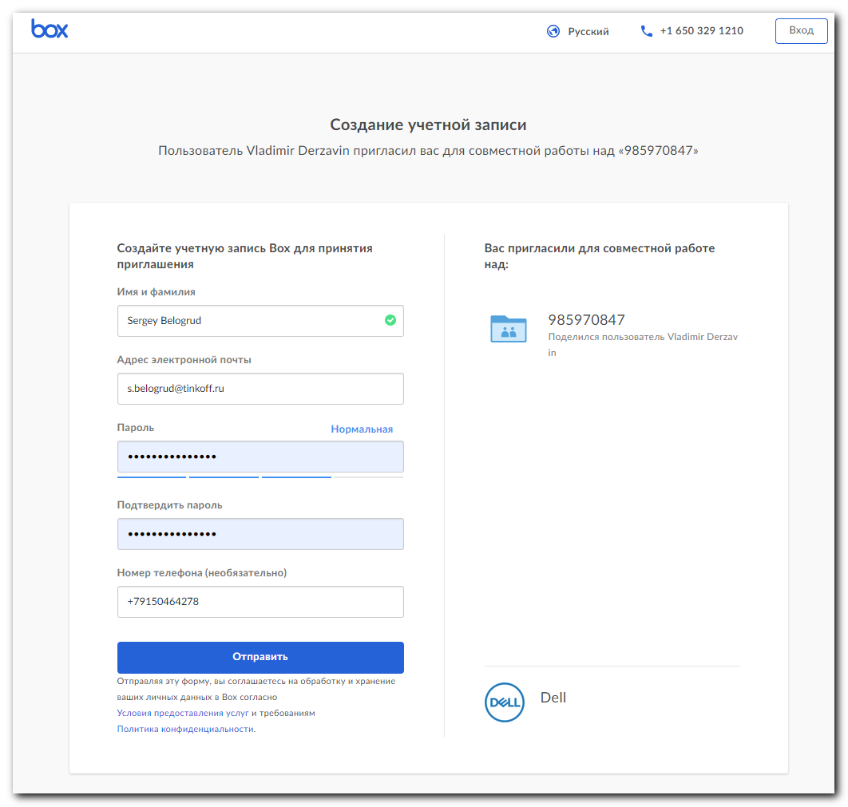

#
# 20190325
# Was failed mdraid on ds-gp-prod-mdw.
# But it looks like it differ problem, than proplems on server-segments.
# Servers-masters have differ version ov NVME cards, than servers-segments.
[12:19:17 root@ds-gp-prod-mdw ~]# nvme list /dev/nvme0
Node SN Model Namespace Usage Format FW Rev
---------------- -------------------- ---------------------------------------- --------- -------------------------- ---------------- --------
/dev/nvme0n1 PHLF813300CG1P0GGN Dell Express Flash NVMe P4500 1.0TB SFF 1 1.00 TB / 1.00 TB 512 B + 0 B QDV1DP15
/dev/nvme1n1 PHLF8125041G1P0GGN Dell Express Flash NVMe P4500 1.0TB SFF 1 1.00 TB / 1.00 TB 512 B + 0 B QDV1DP15
[12:21:48 root@ds-gp-prod-mdw ~]#

# Here are cards on server-segment.
[11:41:57 root@ds-gp-prod-sdw01 ~]# nvme list /dev/nvme0
Node SN Model Namespace Usage Format FW Rev
---------------- -------------------- ---------------------------------------- --------- -------------------------- ---------------- --------
/dev/nvme0n1 S3B1NA0JA02975 Dell Express Flash PM1725a 3.2TB AIC 1 3.20 TB / 3.20 TB 512 B + 0 B 1.0.4
/dev/nvme1n1 S3B1NA0J900263 Dell Express Flash PM1725a 3.2TB AIC 1 3.20 TB / 3.20 TB 512 B + 0 B 1.0.4
/dev/nvme2n1 S3B1NA0J900207 Dell Express Flash PM1725a 3.2TB AIC 1 3.20 TB / 3.20 TB 512 B + 0 B 1.0.4
/dev/nvme3n1 S3B1NA0J900230 Dell Express Flash PM1725a 3.2TB AIC 1 3.20 TB / 3.20 TB 512 B + 0 B 1.0.4
[11:42:03 root@ds-gp-prod-sdw01 ~]#

#
# On /var/log/messages I’ve found only follow.
Mar 23 11:00:02 ds-gp-prod-mdw systemd: Started Session 453 of user gpadmin.
Mar 23 11:00:07 ds-gp-prod-mdw systemd-logind: Removed session 453.
Mar 23 11:00:17 ds-gp-prod-mdw kernel: nvme nvme0: resetting controller
Mar 23 11:00:25 ds-gp-prod-mdw kernel: nvme nvme1: resetting controller
Mar 23 11:00:42 ds-gp-prod-mdw puppet-agent[147104]: Applied catalog in 1.58 seconds
Mar 23 11:00:50 ds-gp-prod-mdw kernel: md/raid1:md0: not clean -- starting background reconstruction
Mar 23 11:00:50 ds-gp-prod-mdw kernel: md/raid1:md0: active with 2 out of 2 mirrors
Mar 23 11:00:50 ds-gp-prod-mdw kernel: md0: detected capacity change from 0 to 1000069595136
Mar 23 11:00:50 ds-gp-prod-mdw kernel: md: resync of RAID array md0
Mar 23 11:01:01 ds-gp-prod-mdw systemd: Created slice User Slice of root.

[support@centos ~]$ list_of_hosts="" ; while read var1_hosts ; do list_of_hosts="${list_of_hosts} ${var1_hosts}" ; done << 'EOF' ; for var1_hosts in ${list_of_hosts} ; do echo "${var1_hosts}" ; SSHPASS="$(pass common/linux)" sshpass -e ssh -t -oStrictHostKeyChecking=no -oPubkeyAuthentication=no bsv@${var1_hosts} "( echo '$(pass common/linux)' | sudo -S -i sh -c 'echo ; echo ; for var1 in 0 1 ; do . /tmp/RetreiveDumps.sh nvme\${var1} ; done ; nvme list > nvme.list.txt ; tar czf /tmp/\$(date +%Y%m%d).\$(hostname).\$(/opt/dell/srvadmin/sbin/racadm getsvctag).nvme.retreivedumps.tgz /root/{*.dump,nvme.list.txt} ' )" ; done #
ds-gp-prod-ext-mdw
EOF

[s.belogrud@TCS4357]# mkdir /drives/c/Users/s.belogrud/Downloads/20190325-1217.nvme.dumps.from.greenplum

[s.belogrud@TCS4357]# scp bsv@ds-gp-prod-ext-mdw:/tmp/20190325*.tgz /drives/c/Users/s.belogrud/Downloads/20190325-1217.nvme.dumps.from.greenplum/

#
# Because its differ model of NVME card - the script cannot get any data from them. The script was made for differ model of card…
#
[12:29:21 root@ds-gp-prod-mdw ~]# . /tmp/RetreiveDumps.sh nvme0
Start time : 12:30:10
#########################################
SCRIPT_NAME=PM1725a Debug Data Retrieval Script
SCRIPT_DATE=2017-04-17
SCRIPT_VERSION=v0.1
#########################################
Memory_Dump Retrieve Start
Reading Memory_Dump Header. Drive = nvme0, Data Transfer Length: 8192 Bytes. Retrieval Offset: 0 NVMe Status:INVALID_OPCODE: The associated command opcode field is not valid(4001) Command Result:00000000
nvme admin-passthru /dev/nvme0 -o 0xF8 --cdw12=0x8000001 --cdw14=0 --cdw10=2048 -data-len=8192 -b -read
Return Status: 0. Dump File Size: 0 Bytes.
Reading Memory_Dump Data. Drive = nvme0, Data Transfer Length: 131072 Bytes. Retrieval Offset: 1 NVMe Status:INVALID_OPCODE: The associated command opcode field is not valid(4001) Command Result:00000000
Return Status: 1. Dump File Size: 0 Bytes.
Memory_Dump Retrieve Complete
Dump File Location: /root/Memory_Dump-128-KB-nvme0-dump-190325_123010.dump
Crash_Dump Retrieve Start
Reading Crash_Dump Header. Drive = nvme0, Data Transfer Length: 8192 Bytes. Retrieval Offset: 0 NVMe Status:INVALID_OPCODE: The associated command opcode field is not valid(4001) Command Result:00000000
nvme admin-passthru /dev/nvme0 -o 0xF8 --cdw12=0x8000000 --cdw14=0 --cdw10=2048 -data-len=8192 -b -read
Return Status: 0. Dump File Size: 0 Bytes.
Reading Crash_Dump Data. Drive = nvme0, Data Transfer Length: 131072 Bytes. Retrieval Offset: 1 NVMe Status:INVALID_OPCODE: The associated command opcode field is not valid(4001) Command Result:00000000
Return Status: 1. Dump File Size: 0 Bytes.
Crash_Dump Retrieve Complete
Dump File Location: /root/Crash_Dump-128-KB-nvme0-dump-190325_123010.dump
Debug_Dump Retrieve Start
Reading Debug_Dump Header. Drive = nvme0, Data Transfer Length: 8192 Bytes. Retrieval Offset: 0 NVMe Status:INVALID_OPCODE: The associated command opcode field is not valid(4001) Command Result:00000000
nvme admin-passthru /dev/nvme0 -o 0xF8 --cdw12=0x8000002 --cdw14=0 --cdw10=2048 -data-len=8192 -b -read
Return Status: 0. Dump File Size: 0 Bytes.
Reading Debug_Dump Data. Drive = nvme0, Data Transfer Length: 131072 Bytes. Retrieval Offset: 1 NVMe Status:INVALID_OPCODE: The associated command opcode field is not valid(4001) Command Result:00000000
Return Status: 1. Dump File Size: 0 Bytes.
Debug_Dump Retrieve Complete
Dump File Location: /root/Debug_Dump-128-KB-nvme0-dump-190325_123010.dump
End time : 12:30:10
#########################################
[12:30:10 root@ds-gp-prod-mdw ~]#

